Activity 2
Ryan Coon
SDD-630
Professor Munirah Alrashed
October 14, 2026

Activity 2.0
After reviewing the provided case studies for mobile applications—FitterMe (fitness app), FeedMe (food ordering app), and a pet diet app, several common sections and questions emerge that these designs consistently address. Typically, each case study begins with an introduction outlining the problem statement or user need the app intends to solve. They then describe the target audience and user personas, followed by detailed user journey maps or workflows that illustrate how users interact with the app. The studies also focus on key features and functionalities, design iterations, and usability testing results. Finally, they reflect on lessons learned and future improvements.
Among these, the FitterMe and FeedMe case studies provide the clearest picture of what the applications will do, with comprehensive user flows and feature breakdowns that highlight how the apps meet specific user needs, fitness tracking and food ordering, respectively. The pet diet app case study, while insightful, is more niche and may be less broadly applicable depending on the intended audience of your own application.
For designing your own app, the FeedMe case study stands out as a strong model due to its structured approach to solving a common problem (food ordering), clear user interface design, and emphasis on user convenience and engagement. It effectively balances functionality with simplicity, which is crucial for user adoption.
Regarding business ideas with the best chance of attracting users, apps that address widespread everyday needs such as fitness tracking (FitterMe) or food ordering (FeedMe), tend to have broader appeal and higher potential for user acquisition. These markets are large, and the apps solve practical problems that many users face regularly. In contrast, niche apps like the pet diet app may attract a smaller, more specialized audience, which can limit downloads unless paired with strong marketing or unique value propositions.
In summary, focusing on common user needs, clear problem-solving features, and intuitive design as demonstrated in the FeedMe and FitterMe case studies, can increase the likelihood of developing a successful and widely adopted mobile application.

Activity 2.1
Essential | Nice to Have | Future Versions
As a user, I want to log my daily energy consumption manually so that I can track my environmental impact. | As a user, I want to scan product barcodes to learn about their environmental impact before purchasing. | As a user, I want the app to integrate with local utility providers for real-time energy and water usage data.
As a user, I want the app to automatically import energy usage data from smart home devices to save time. | As a user, I want to participate in community challenges to reduce collective environmental footprints. | As a user, I want to receive rewards or discounts from eco-friendly brands as incentives for sustainable behavior.
As a user, I want to track my transportation methods (car, bike, public transit) so that I can monitor my travel emissions. | As a user, I want to share my achievements and progress on social media to encourage others.
As a user, I want to see a personalized dashboard showing my total environmental footprint to understand my impact. | As a user, I want to join groups within the app to connect with other environmentally conscious users.
As a user, I want to receive tailored recommendations to reduce my carbon footprint based on my logged data. | As a user, I want to access educational content about sustainability and climate change within the app.
As a user, I want to set goals for reducing my environmental impact and track my progress over time.

As a user, I want to receive reminders to perform eco-friendly actions, such as recycling or turning off lights.

Activity 2.2
Wireframes
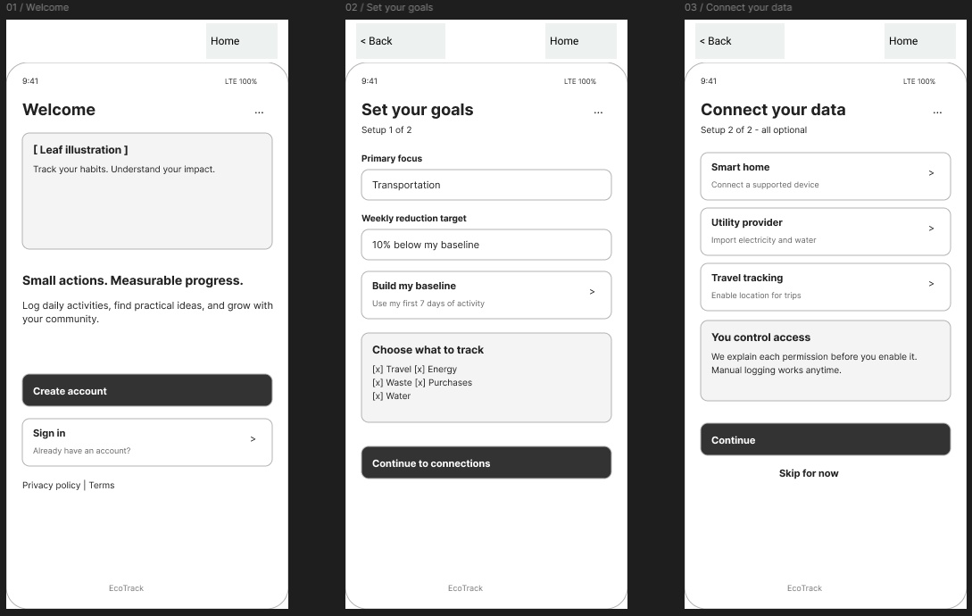
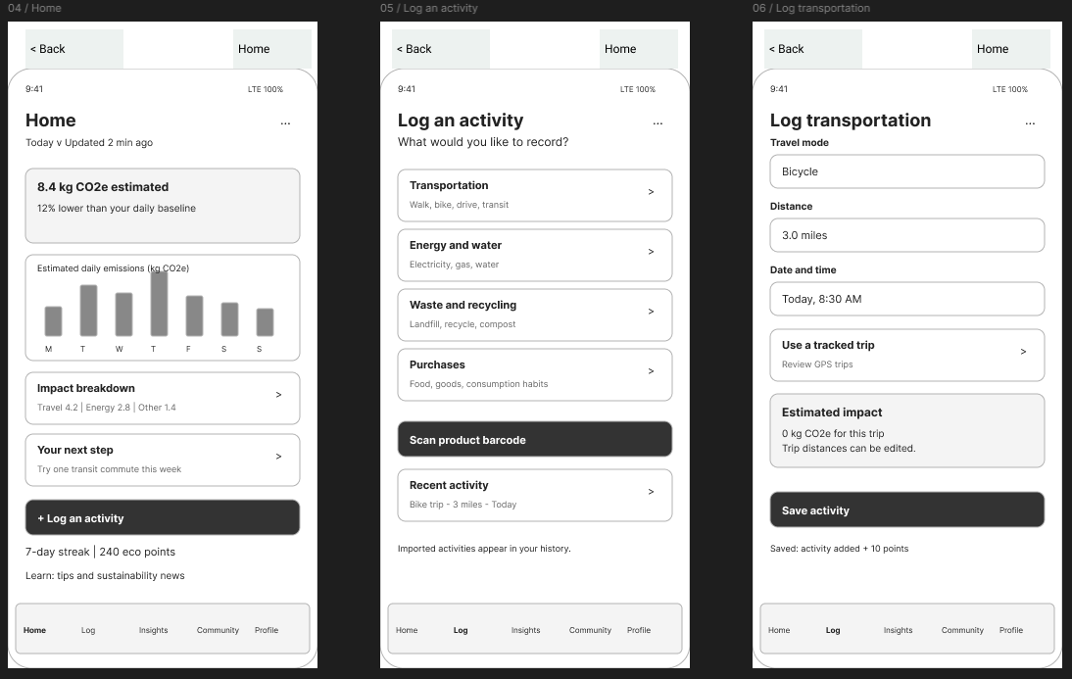
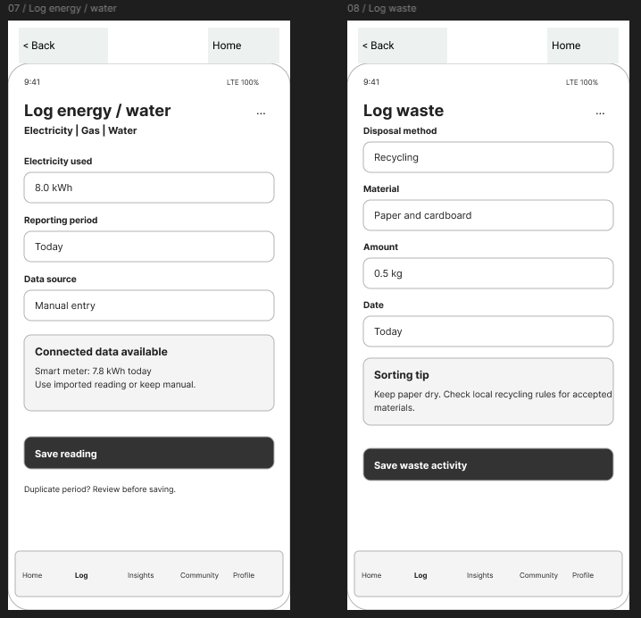
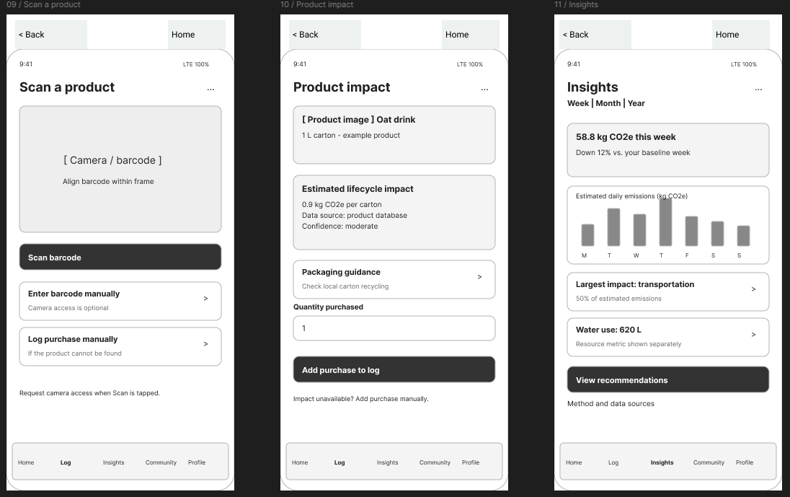
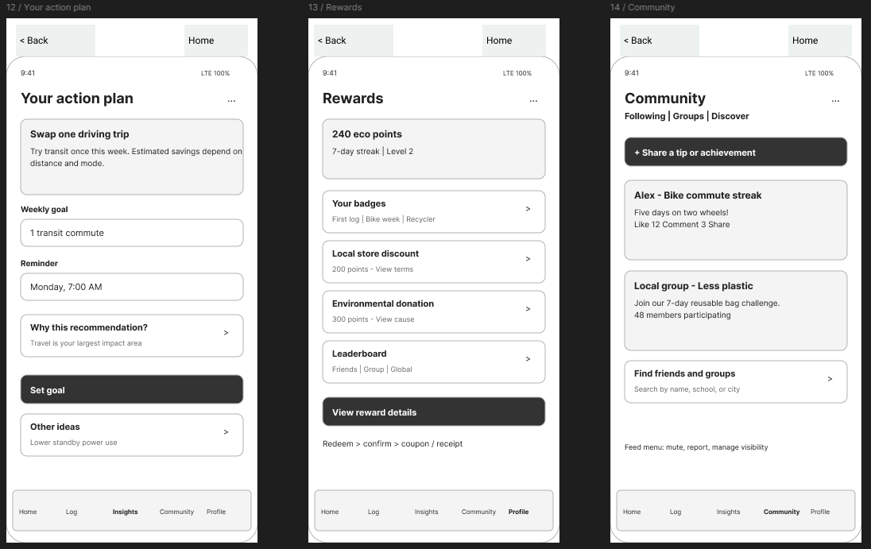
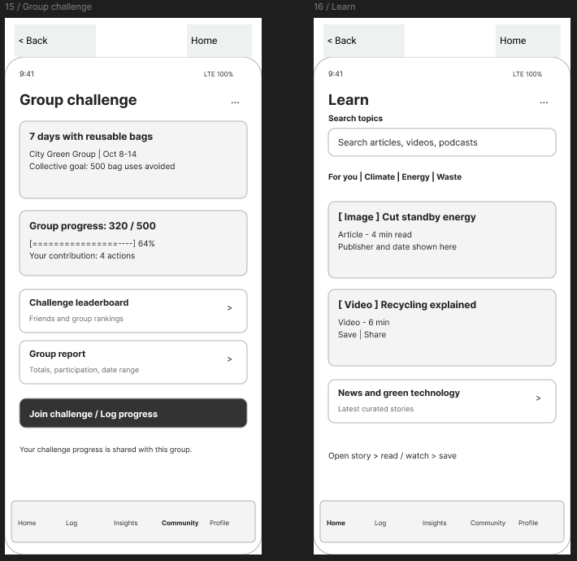
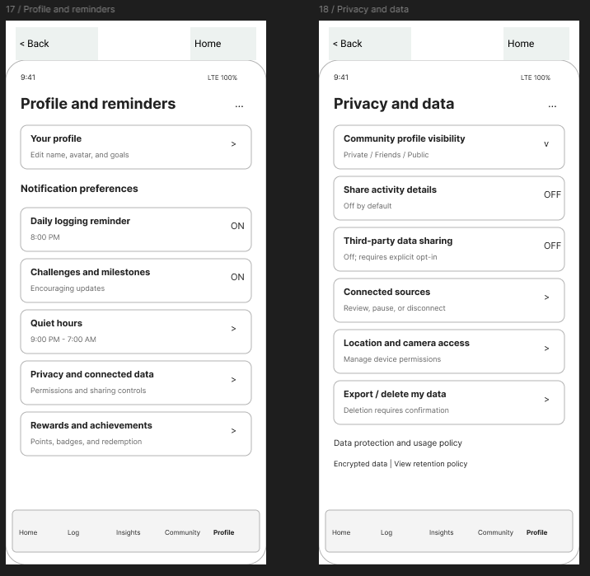
Screencast URL:
https://www.loom.com/share/49f71e61769e4a74912406e3974fbb56

